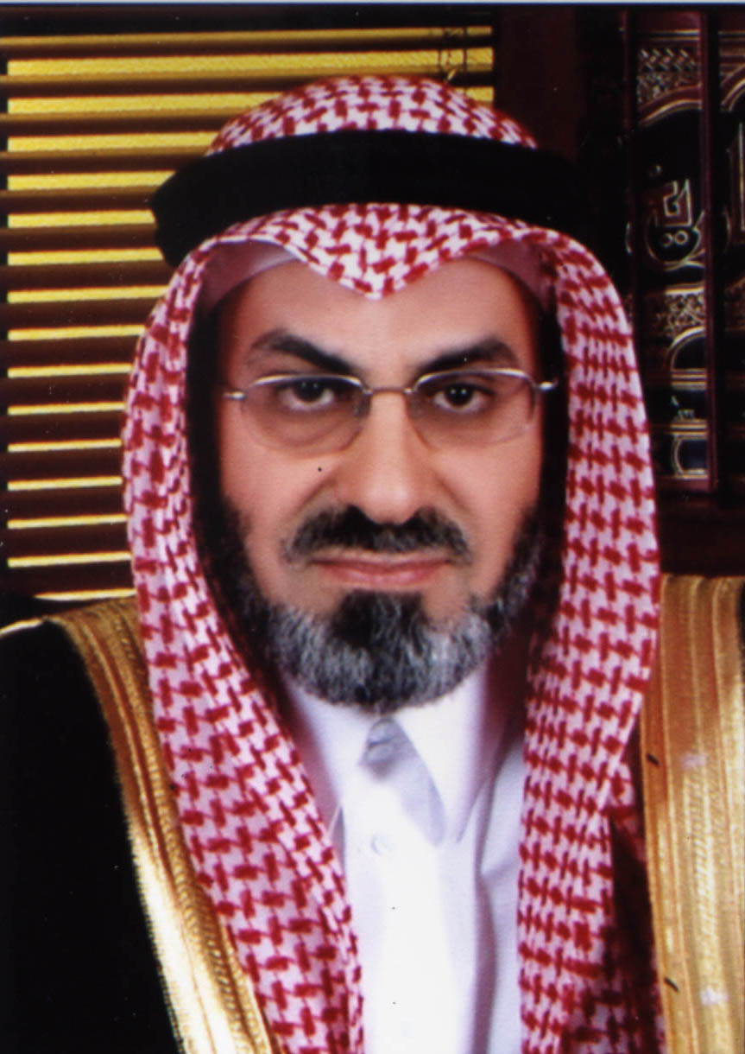
CURRICULUM VITAE

Personal
Name : Dr. Ibrahim H. Al-Quayid
Nationality : Saudi Arabian

Education :

Ph. D, Education (English Language Education and Teaching Methods), Indiana University, USA, 1403 H (1983 AD).
- MA, English Language Teaching, Indiana University, USA, 1403 H (1983 AD).
- BA, English Language and History, King Saud University, 1395 H, (1975 AD).
- Specialized Training Courses in Train the Trainers, Modern Training Techniques, and Administrative and Educational Consultations (on-going activity).

PRESENT OCCUPATION
- Elected Member of Riyadh Municipal Council.
- President, Dar Al-Marifa for Human Development, this includes:
  - Dar Al-Marifa for Human Development
  - Al-Quayid Center for Translation
  - Annashir International House (Publishing and Distribution)
  - Makaniz for Information Technology

- Chief Consultant and Team Leader, Consultation Studies Team of Dar Al-Marifa.
  - Supervised a number of Ph. D. and MA dissertations; construction of educational curriculum and syllabus.
  - Supervised over thirty (30) administrative, educational, academic, and social consultancy studies during the past seven (7) years.
  - Supervised publication of over seventy (70) books during the past seven (7) years.

- Advisor, numerous governmental agencies and private sector institutions. Consultations included: administrative aspects, activation of jobs and Saudization, feasibility studies, curriculum and program design, educational aspects, social and Islamic issues, and conference and seminar programs.

- Training Expert
Designed and developed numerous administrative courses and self-improvement and personality efficiency program; reserves intellectual property rights for such courses which include:
  - The Ten Habits of Highly Successful Personality
  - Preparing and writing professional Business reports.
  - Modern strategies in Train the trainers.
  - Successful Self-Management
Such courses are conducted on a yearly regular basis at numerous institutions at government, private, and national levels.
  - Member in numerous Scientific Associations in the field of consultancy and training (Saudi Management Association, Arab Society for Human Resources Development, Saudi Association for educational and psychological Sciences, American Society for Training and Development, International Federation for training and Development Organizations, and Arab Society for Management).

- Administrative Advisor: conducted a variety of general purpose lectures, seminars, and workshops in the following topics:
  - The Ten Habits of Highly Successful Personality
  - Planning and Time Management
  - Successful Self-Management
  - Successful Administrator in the globalization era
  - Educational Supervision and Training
  - Work under pressure and crisis
  - Changes Management
  - Balance between work and the private life

EMPLOYMENT BACKGROUND
President of Dar Al-Marifa Group. | - 1996 – Present
Deputy Dean, College of Languages and Translation, King Saud University, Riyadh, KSA. | - 1994 – 1996
President, Asian Languages and Translation Department, College of Languages and Translation, King Saud University, Riyadh, KSA. | - 1992 – 1994
General Manager, Training and Scholarship Training, Ministry of Health, Riyadh, KSA. | - 1986 – 1987
Assistant Professor, College of Languages and Translation, King Saud University, Riyadh, KSA. | - 1983 – 1993
Administrator and Lecturer, King Saud University, Riyadh, KSA. | - 1975 – 1977
Student, higher education pursuit, USA. | - 1977 – 1983
During the 25 years of work for King Saud University, I conducted a number of educational curricula at the English Department and the College of Languages and Translation including a diversity of English Communication courses (spoken, written), Linguistics, phonology, English Language history, English Language curricula, the theory of Translation, Introduction to Translation, translation difficulties, and various-aspect translations. In addition, I have designed a variety of academic programs in education and teaching English Language. A member and chairman of numerous scientific and consultancy committees at the Department level, the College of Languages and Translation level as well as the University level; acted as representative of the College of Languages and Translation at the King Saud University Board.

PUBLISHED WORKS
    - Author of Ten (10) books and Thirty (30) academic researches. (“The Ten Habits of Highly Successful Personality” and “Your Personal Guide for Happiness and Success” are the best seller Arabic books published by Dr. Al-Quayid.)
    - Translated three (3) books from English to Arabic.
    - Supervised translation and publishing of more than two hundred (200) scientific works (books, researches, and studies) since the inception of his private business in 1997.

MAJOR PUBLIC ACTIVITIES

    - Represented the Kingdom of Saudi Arabia in many international and scientific conferences; presided a number of out-of-country delegations (During assignment at King Saud University and the World Assembly for Muslim Youth).
    - Presided programs of a variety of Islamic World conferences organized by the World Assembly for Muslim Youth.
    - Participation in the preparation and implementation of numerous radio and TV programs.
    - Member of a number of national and international committees.
    - Attended regional and world conferences in the field of management consultation and training.

VOLUNTARY ASSIGNMENTS

Assistant Secretary General, The World Assembly for Muslim Youth and member of the General Secretariat thereof | - 1985 – 1998
Member, The World Assembly for Muslim Youth (President and member of a number of committees). | - 1985 – Present
Vice Chairman of the Board of Directors, Al-Riyadh Manarat Schools. | - 1984 – 1994
Vice Chairman of the Board, Huraimla Area Charitable Society | - 1990 – Present
Honorary Member, Objective Studies Institute (New Delhi, India). | - 2001 – Present
Member of Riyadh Chamber of Commerce Committee for private management and training institutions. | - 2001 – Present
Member of the Saudi Council for the Chambers of Commerce Committee for international relations | - 2003 – Present
Member of the supervisory Council of the International Educational Organization (World Muslim League). | - 2003 – Present
Member of The National Society For Human Rights | - 2004 – Present

